MBC Meeting Minutes – May 13, 2020

Those Present:
District #1 Kevin Noffsinger, Treasurer
District #2 Mark Reif
District #3 Greg Ackerman, Chairman
District #4 Clint Stoutenburg, Vice-Chairman
District #5 Allen Bischer
District #6 Ross Voelker
District #7 Jessica Rader
At Large Steve Ewald
Shipper Representative Neil French
Executive Secretary Joe Cramer

Those Absent:

Others Present:
Scott Bales, MSU Dry Bean Specialist
Heather Throne – MDARD

Chairman Ackerman welcomed everyone to the first virtual meeting in MBC history and called the meeting to order at 8:00 p.m. Ackerman noted that under the Governor’s EO that allows us to meet virtually roll call votes are required/recorded. The voting record for this meeting will be attached.

APPROVAL OF AGENDA: Cramer asked to add 9.d - MSU-MBC Dry Bean Specialist Position to the agenda. A motion was made by Bischer to approve the agenda as amended. Voelker supported the motion. Motion passed.

PUBLIC COMMENT: There was none.

APPROVAL OF MINUTES: Minutes from the March 4, 2020 Commission meeting were presented and reviewed. A motion was made by Bischer with support from Voelker to approve the minutes as amended. Motion passed.

FINANCIAL REPORT: Cramer presented MBC and PRAB YTD P&L reports including budget comparisons for September 2019 – April 2020. Cramer highlighted some revenue and expense line items as compared to budget. A brief discussion followed. A motion was made by French to accept the report as presented. Noffsinger supported the motion. Motion passed.

Cramer also presented a first draft of budgets for FY 2020-2021. He will have a second draft at our next meeting and seek approval at the August meeting as required. Commissioners will also be presented with FY 2019-2020 MBC budget amendments at our next meeting.
MDARD UPDATE - Heather Throne

- $1.9 million of the total SCBG dollars have been allocated to Michigan.
- Both of MBC’s SCBG applications have been forwarded to USDA for approval. Throne noted that the application nicknames “Research” scored the highest of the applications submitted this year. Approval is expected in late August/September.
- Value Added Grant applications are on hold due to the COVID-19 pandemic.
- Director McDowell continues to host biweekly COVID-19 updates. Cramer and Throne both attend regularly. The Direction announced that Dr. Averill, Deputy Director will be stepping down. Jamie Zmitko-Sumers has been named to fill the position temporarily.

MBS Update – Neil French

- MBS Trustees will have their first meeting with new MABA president Chuck Lipprestru on May 21, 2020.
- French’s data and observations suggest Michigan’s dry bean acreage will be up app. 20%. In comparison, the Minn-Dak region will be up but not quite as much by percentage. Most expect the increase in Minn-Dak to be largely pinto beans.
- Despite early forecast of seed shortages, there appears to be an adequate supply navy bean and black bean seed.
- Domestic shipments remain steady. Shipments to export markets vary. For example, Europe remains steady, but Mexico has slowed.

EXECUTIVE DIRECTOR’S REPORT

- SEED SUPPLY was an agenda item at our March meeting with concern being raised about seed availability for our industry this year and beyond. Commissioners also discussed at length their concern about breeding programs exporting their genetics, varieties, seed, etc. to what were labeled non-traditional production regions. Cramer communicated this to MSU’s breeding program leadership and the leadership at Michigan Crop Improvement. A meeting was scheduled between the three groups to discuss the concern. A good discussion was held. As expected, sustaining well-funded programs is the driver. If our seed dealers and growers supported the program, funding would follow, and the offshore interest would not be as attractive. Cramer will continue to work with both programs to come up with a game plan that serve in the best interest of all three stakeholders.

- COVID-19 has delayed the DRY BEAN REVENUE INSURANCE discussion that has been taking place. Commissioner encourage Cramer to continue to work with Northarvest and Watts & Associates to review, evaluation, and develop recommendations that will simplify price discovery, improve the accuracy of the data collected during the discover period and guarantee the confidentiality of the participants involved in the price discovery process -as directed during the March 4th meeting.

- COVID-19 has caused us to be creative with new ways to reach consumers. As dry and canned bean sales have increased dramatically during the pandemic and new video and blog series was created to help consumers learn different ways to consume the healthy bean inventory in their pantry. Hopefully, they will be long term consumers.

- Michigan Food Bank Council - continues to be pressed for food. The MBS and MBC partnered to purchase 7,000 x 2 lb. packages of Michigan Beans to donate to the Council. This necessary logistics have been completed. Commissioner French was also able to secure a donation of 5,000 x 16 oz cans of Bush Beans which is also greatly appreciated. Our appreciation will be passed along to the leadership at Bush Bros. Delivery is expected next Wednesday.

- SCBG Applications – as noted in the MDARD report earlier, applications labeled “Fertility-Phase III” and “Marketing” are pending. We are optimistic that we will receive approval. If approved, the 18-month agreements will commence in October 2020.

- The Milling Project is moving forward however the projected July start up is likely delayed. The Marketing Grant, if approved, should complement the Milling Project.

- Cramer talked in generalities about the unusual situation we find ourselves in with little to no supply and heightened demand. Projections suggest that elevator storage will be (nearly) cleaned out before harvest meaning, that the entire supply will be dependent on the success of this growing season as we try to re-fill any empty supply pipeline.

DRY BEAN SPECIALIST REPORT – (PP Presentation)

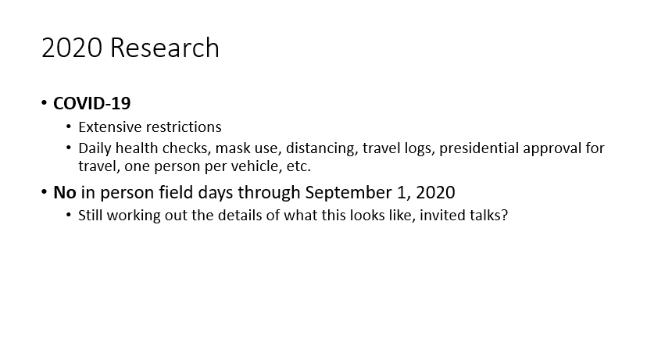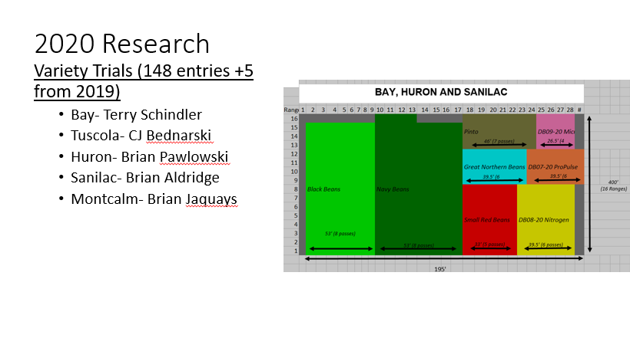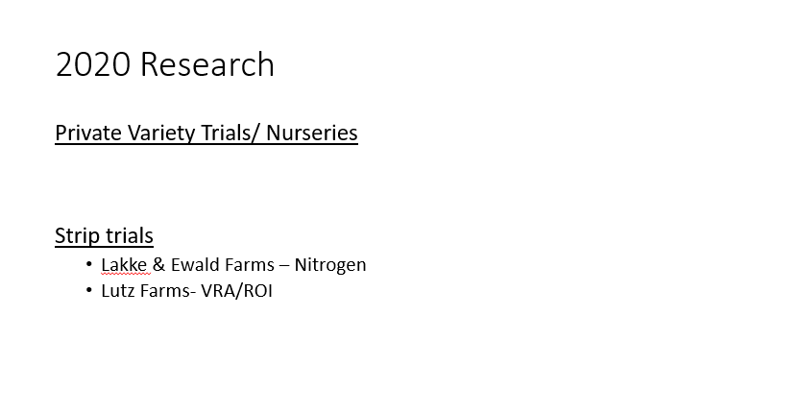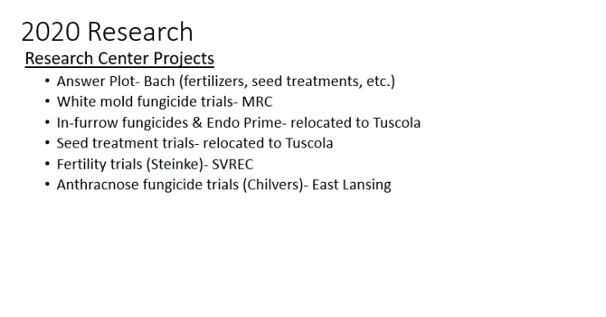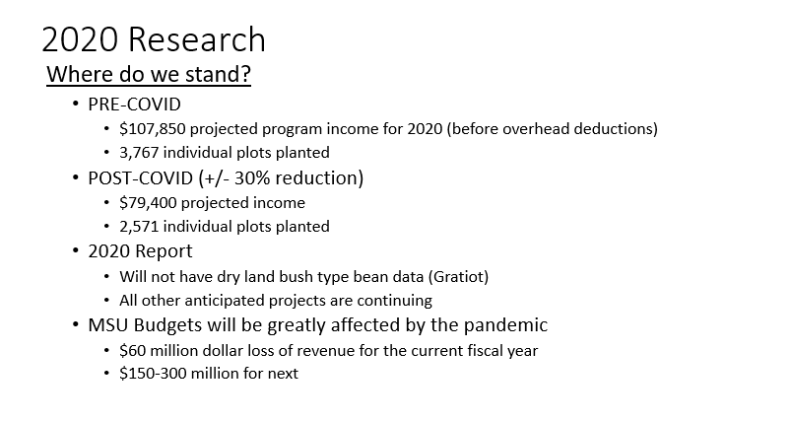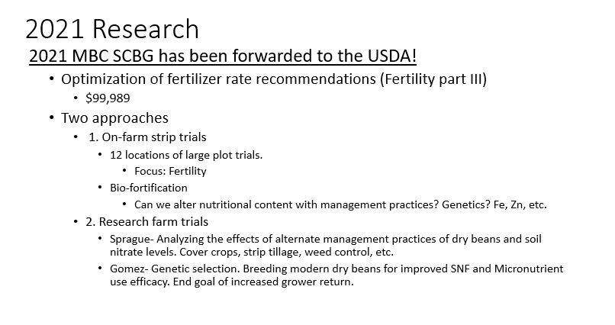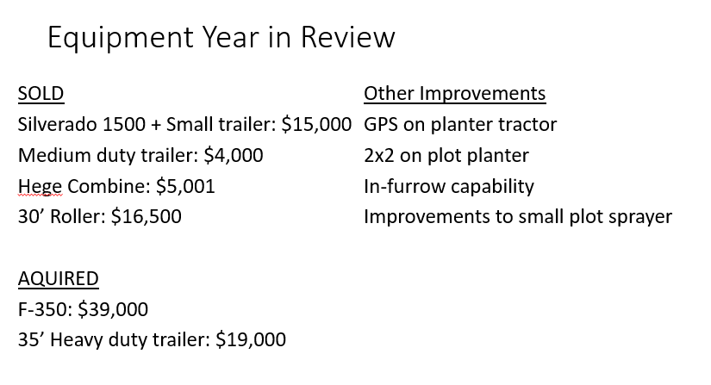
- Dry Bean Specialist Position - Michigan State University requested confirmation that MBC does intend to fund their share of the Dry Bean Specialist position for FY 2020-2021. Commissioners agreed that the partnership has worked out very well to date and expressed their satisfaction with Dry Bean Specialist Scott Bales. Ackerman moved to continue funding the position for FY 2020-2021. Bischer supported. Motion passed.

USDBC UPDATE

- Executive Committee continues to work with Rebecca to adapt strategies into effective formats in today’s world markets.
- The IPC has moved toward more frequent discussions with overseas representatives. Regional reports will move toward more frequent updates as well. A schedule is being laid out for presentation to the industry to offer webinars that address various topics of interest.
- The Innovation Committee is in the process of contracting with a Nutritionist. Hopefully, the position will be filled late spring/early summer.
- Plans for BeanCon21 continue to move forward.
- Cramer will act as the moderator for a #GPCasktheexperts Series webinar on May 28th. The webinar will be specific to black beans.

With no further business, Chairman Ackerman adjourned the meeting at 9:53 PM.

Respectfully,

Joe Cramer

Joe Cramer, Executive Secretary

